Lesson 4 pt 1: Legislative Unit pt 1, 4-3-2020
Pictures of the U.S. Capitol (Congress meets/makes public policy here)
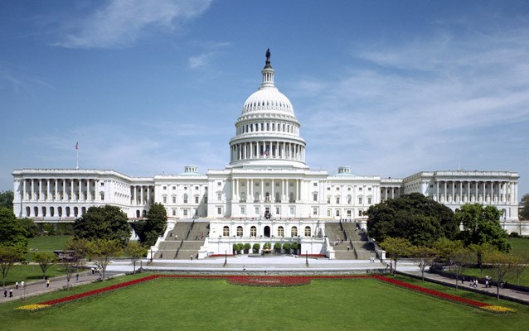

House Chamber (below):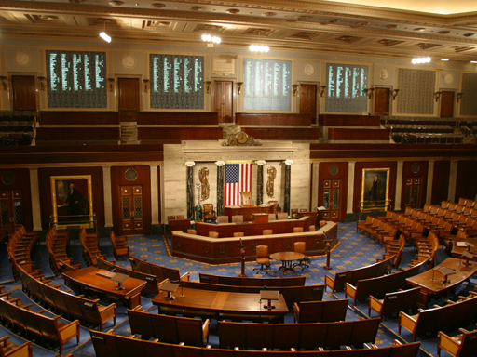
Speaker of the House: Nancy Pelosi (D-CA)
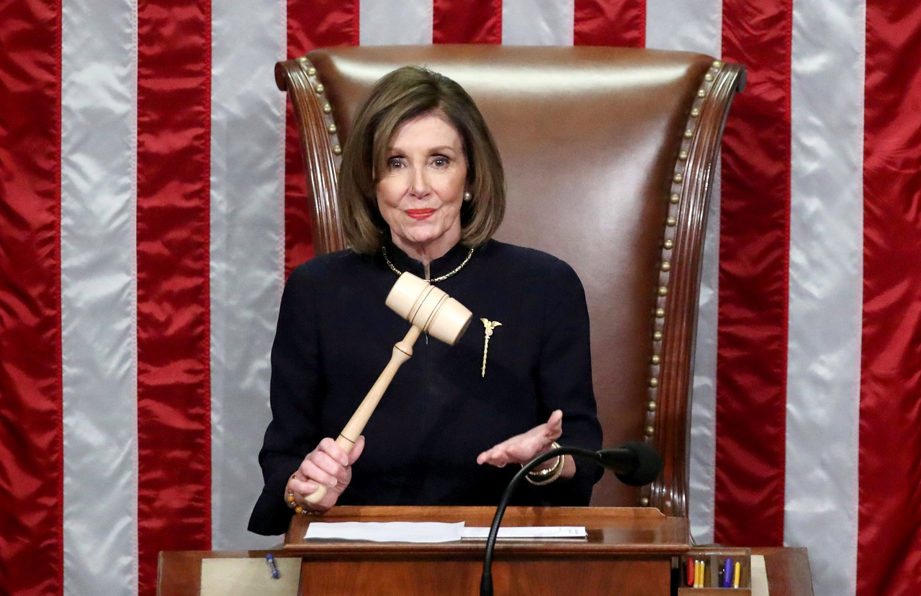

Senate Chamber (below):
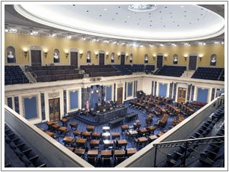
Senate Majority Leader: Mitch McConnell (R-KY)
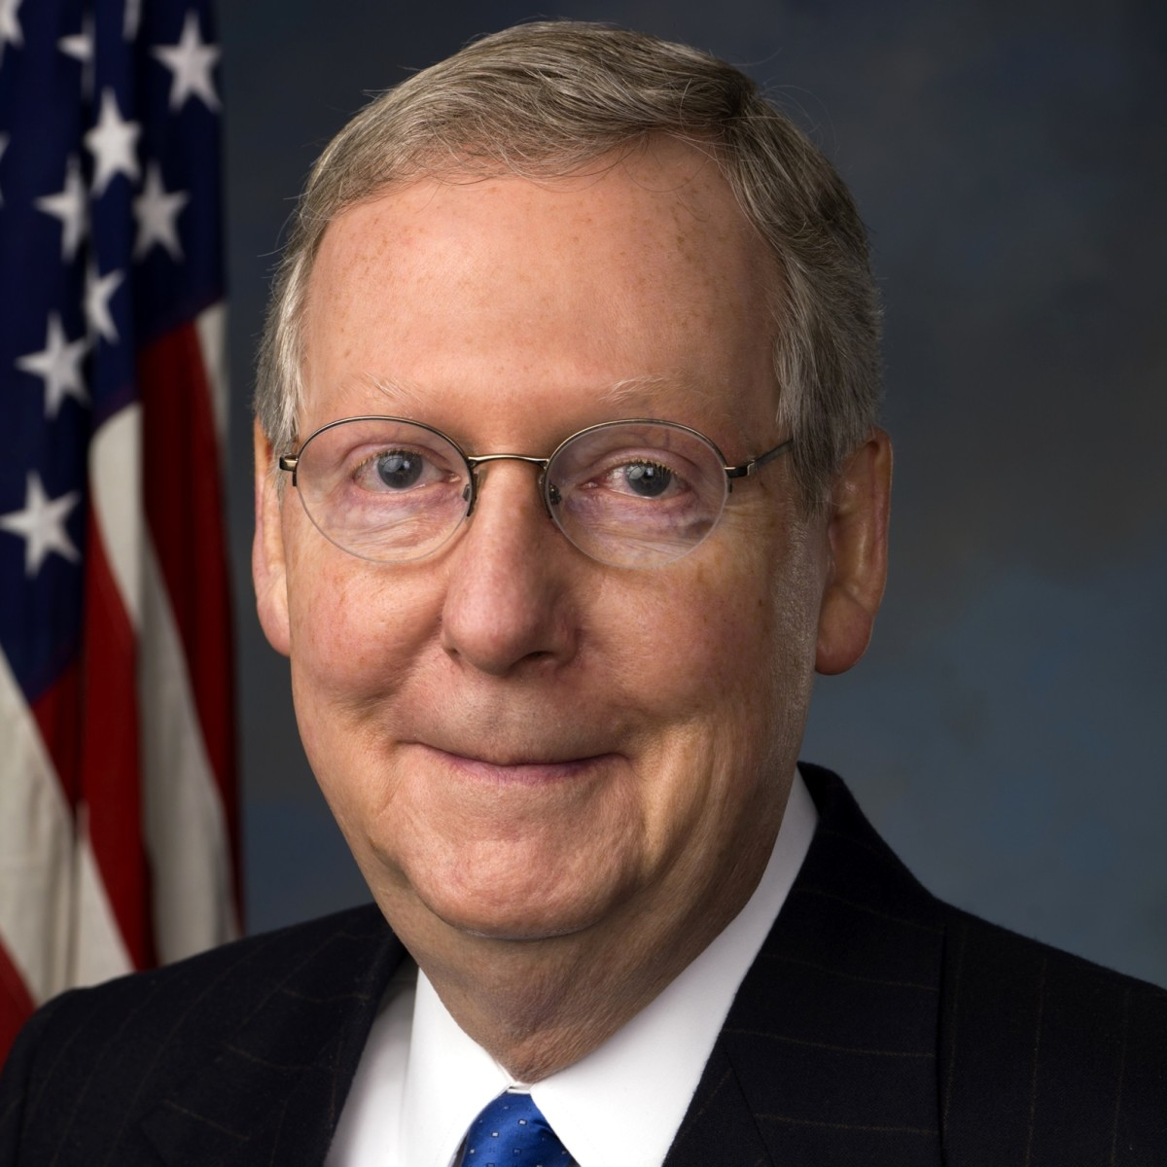

A.P. U.S. GOV Lesson 4 on the Legislative Branch, 4-2-20

- The Structure of Congress
- Bicameral (two houses or chambers) that write laws for the nation and has oversight power over the bureaucracy [i.e. the group of cabinet departments and agencies in the executive branch that help the president enforce the law: E.G. The Department of Homeland Security or the Federal Communications Commission (F.C.C.) or the Environmental Protection Agency (E.P.A.), etc]

- House of Representatives has 435 members, elected every two years; two-year terms; no term limits; represent the constituents in their districts only. House incumbent election rates are high (90% or more), since most House seats are redistricted by the majority party in the state legislature, which creates “safe seats” for that majority party.

- Senate: 100 members; six-year terms; no term limits; elections are staggered every two years (i.e. 1/3 of the Senate is up for re-election every two years). Elections for Senate seats are far more competitive than elections for House seats because Senate seats have are not redistricted, and thus can’t create “safe-seats”.

- Every 10 years the federal government completes the census to count the population in order to determine the number of seats a state should get based on its population (reapportionment). Each state must then redraw its congressional district boundaries to make sure the population in each district is roughly equal in population (redistricting). State legislatures control how the districts are drawn and as much as legally possible, the legislature will gerrymander the district boundaries to give the majority party an advantage in future elections by creating “safe-seats”. A more detailed explanation of this process is at the end of this document.

- Congressional Powers
- Delegated (enumerated) powers listed for Congress in the Constitution: creating laws, taxing, borrowing money, regulating commerce, raising an army, creating and making rules for federal courts, making any law that is “necessary and proper” (i.e. creating implied powers) to carry out the delegated powers.

- Congress is given much control over making a budget and controlling budgetary spending. The “power of the purse”, as this is known gives Congress the power to influence the president and bureaucrats by withholding or putting conditions on funding for various projects (E.G. “the Wall”, a new aircraft carrier, funding to create new technology that will reduce global warming, etc.)

Pertinent nomenclature:
an “authorization bill” states what amount of money/funding a particular project/program should get
“appropriations bill” states what amount of money/funding a particular project/program will get.
Implied power for both the House and Senate: passing a federal budget

- Each house has unique powers: only the House may initiate tax laws and spending bills. It is the House Ways and Means Committee that oversees taxing and spending legislation. The Senate only has amending power on revenue bills.

- Discretionary Spending: In American public finance, discretionary spending is government spending implemented through an appropriations bill. This spending is an optional part of fiscal policy, in contrast to entitlement programs for which funding is mandatory and determined by the number of eligible recipients. Examples of discretionary spending are national defense, foreign aid, education and transportation.

- Mandatory Spending: Mandatory—or direct—spending includes spending for entitlement programs and certain other payments to people, businesses, and state and local governments. Mandatory spending is generally governed by statutory criteria; it is not normally set by annual appropriation acts. Outlays for the nation’s three largest entitlement programs (Social Security, Medicare, and Medicaid) and for many smaller programs (unemployment compensation, retirement programs for federal employees, student loans, and deposit insurance, for example) are mandatory spending. Social Security and some other mandatory spending programs are in effect indefinitely, but some (for example, some agriculture programs) expire at the end of a given period. Roughly 60 percent of federal spending in 2012 was mandatory.
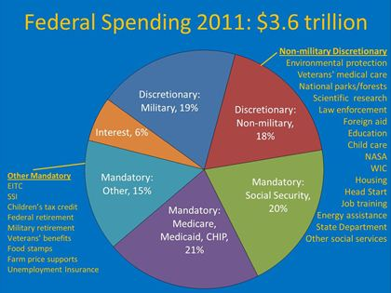

- Senate’s unique powers include (checks on the executive branch here):
-Senate ratifies treaties negotiated by Pres w/ at least 2/3 “yes” vote
-Senate also confirms (advise and consent function) federal judges, cabinet department secretaries, and ambassadors nominated by the president
- Non-Legislative Tasks of Congress:
- -representing constituents: A “trustee delegate” is a member of the House or Senate who votes on a bill in terms of how it will benefit the population of the U.S. at large as opposed to just her/his constituents. “Instructed delegate” is a member of the House or Senate who votes on a bill in terms of how it will benefit just her/his constituents. A politico delegate combines trustee and instructed.

- Oversight of the bureaucracy , i.e. those Executive Branch Agencies that help the president enforce the law like the Department of Homeland Security, Department of Defense, Department of Education, F.C.C. (Federal Communications Commission), F.D.A. (Food and Drug Administration).

- Oversight includes Congress checking to see if the bureaucratic departments and agencies are correctly spending funds that Congress has provided for them AND Congress using their select committees and standing committees to hold hearings to (usually in front of television cameras!) to make sure that the bureaucratic departments and agencies are carrying out the laws that Congress has made.

- Public education: representatives and senators hold hearings and have floor debates to increase public awareness of government, issues in society, and public policy (think of issues like gun control, tax cuts, health care reform, social security reform).

- Impeachment articles are voted on in the House (simple majority vote passes the impeachment charges). If passed by the House (only a simple majority is required) then the articles are literally carried over to the Senate, where the Senate holds a trial to determine guilt or innocence,. If at least 2/3 of Senators vote guilty, then the impeached person is removed from office. Federal judges, cabinet secretaries, Pres, and V.P. CAN all be impeached. Senators and House members CANNOT be impeached.

III. BIG QUESTION: What functions/powers and rules in the House and Senate affects the policymaking process ? (A.K.A.: the Legislative Proces)

- The legislative process is slow and complicated to prevent Congress from acting hastily and creating bad legislation.

- The legislative process requires the two houses to work cooperatively with each other.
- Logrolling: when reps or senators agree to vote for each other’s bills
- Because there are lots of Representatives in the House, the process by which bills are debated is limited. The Senate is smaller and therefore has fewer rules governing the debate process, including unlimited debate time.

- Unlike the Senate, the House has a rules committee that determines how long a bill will be debated and how many amendments (A.K.A. riders) will be allowed to be added to the bill (This all-powerful/all-important committee is called The House Rules Committee!).

- The Rules Committee can kill a bill by delaying a vote on the bill or by making it easy to add “poison pill” amendments (A.K.A. “killer” amendments). The Rules Committee also has the power to bring bills up for an immediate floor vote.

- Committee of the Whole (ONLY USED IN THE HOUSE): the whole membership of a legislative house sitting as a committee and operating under informal rules. In the United States House of Representatives, a Committee of the Whole House is a congressional committee that includes all members of the House. It is used only to schedules bills involving money issues. It arose from the requirement in Article One of the United States Constitution that all revenue bills originate in the House of Representatives. It can affect the legislative process by ALLOWING MORE DEBATE TIME; in other words, it extends debate time in the House.

- Discharge petition (ONLY USED IN THE HOUSE): A discharge petition allows a majority of the House of Representatives, or 218 elected officials, to force a bill onto the floor, where it will be debated and ultimately voted on. Here’s how it works: If a bill has been introduced and referred to committee for at least 30 days, any House member can file a motion with the Clerk of the House to discharge the bill from committee. If 218 members sign onto the petition, the bill becomes eligible for discharge with a vote (after seven days). It can affect the legislative process by making it faster since releasing it from a committee could allow it to be debated on and voted on.

- While the House strictly controls debate, the Senate does not. There are no time restraints placed on Senators. Soooooo, Senate has unlimited debate time: the filibuster (ONLY IN THE Senate) occurs when a senator gets up and speaks for as long as s/he can (hours possibly) in order to delay or stop (kill) the vote on a bill (its role in lawmaking process); usually the minority party uses the filibuster as a tool to keep the majority party from passing every bill it wants to; sometimes a member of the majority party will filibuster a bill though. The only way to stop a filibuster is through a “cloture vote”. This vote requires that at least 60 senators vote ‘yes” to stop the filibuster.
- Unanimous Consent (ONLY USED IN THE SENATE): Unanimous consent agreements expedite the course of legislation (i.e. SPEED POLICY-MAKING PROCESS UP!). Lawmakers ask for unanimous consent so that they can speed up what they believe to be uncontroversial business that would otherwise be delayed by holding a vote or going through the rules. Among the common unanimous consent (UC) requests made by legislators in hearings or on the floor of their chamber:
“I ask unanimous consent that [a specific staffer] be granted floor privileges.”
“I ask unanimous consent that the bill be considered passed without objection.”

It only takes one objection from another present lawmaker to block a unanimous consent request. Objections are usually only made with respect to UC requests for the passage or consideration of a bill that would disrupt the floor schedule or is controversial enough that the objector would prefer it be considered in a more deliberative manner.

UC agreements typically limit the amount of debate on a given matter or the number of amendments to a bill (if any) that will be considered.

- Holds (ONLY USED IN THE SENATE): An informal practice by which a senator informs his or her floor leader that he or she does not wish a particular bill or other measure to reach the floor for consideration (i.e. for debate and a vote). The majority leader need not follow the senator's wishes, but is on notice that the opposing senator may filibuster any motion to proceed to consider the measure. The hold makes it very easy for individual lawmakers to stall ongoing debates. Since anyone can slow down or halt the chamber’s business, the Senate must rely on collegiality to keep business moving forward. The ability to place a hold would allow that senator an opportunity to study the legislation and to reflect on its implications before moving forward with further debate and voting. Often it is used for nefarious means, such as stopping a bill from going to the floor for debate or vote, or keeping a president’s nominees for federal judgeships or cabinet secretaries from being confirmed.

- “Pet project” riders (a rider is an amendment tacked on to a bill) that are designed to bring federal money home to a state (or a district) is called “pork barrel” spending. Oftentimes these riders are the result of Logrolling (i.e. when reps or senators agree to vote for each other’s bills…I scratch your back you scratch mine…you vote for my pet project, I vote for yours…quid pro quo)

- Since bills passed in each house are not identical very often, but rather similar, both versions must be sent to a conference committee. A conference committee is a type of joint committee, which is made up of members from both the House and Senate. Its role in the legislative process is to reconcile the differences in two similar bills from the House and Senate in order to create a single identical bill. Once reconciled the bill goes back to the House and Senate to be voted on. If it passes with a simple majority, the bill goes to the president to sign, veto, etc.

- Congressional Leadership (How does the leadership in Congress affect the policymaking process?)

Leadership in the House:
- Speaker of the House: most powerful position in the House; s/he is leader of the H.O.R.; If pres/V.P. die then Speaker becomes president; Speaker can appoint members to committees as well as committee chairs…of special significance is the House Rules Committee which schedules bills to go to the floor for debate and a vote, so Speaker can control the legislative agenda; Speaker is a member if the H.O.R. and is elected by the majority party in the House
- House Majority Leader: second in command to the Speaker and helps Speaker chose reps for committees
- House Minority Leader: leader of the minority party in the H.O.R.
- Majority Whip and Minority Whip: both function to try and get their respective party members together in terms of how they vote on bills.

Leadership in the Senate:
- Senate Majority Leader: most powerful position in the Senate; s/he is leader of the Senate.; The leader can appoint members to committees as well as committee chairs… he schedules bills to the floor for debate and a vote, so The Leader can control the legislative agenda…BIG POWER…a Senate Majority leader can literally keep bills from ever coming to the floor for a debate and/or vote!!!
- Senate Minority Leader: leader of the minority party in the Senate.
- Majority Whip and Minority Whip: both function to try and get their respective party members together in terms of how they vote on bills

-Vice President, upon his/her election, becomes the President of the Senate. No power or duties to speak of here in this role, except for the fact that s/he can vote to break a tie vote in the Senate.
-Senate hold trial to find an impeached individual guilty or not guilty (2/3 vote at least).

- Legislation by Committee:

- Most of the legislative business of Congress occurs in committees. The majority party of each house holds all the committee chairs. The majority party will also hold a majority of seats on each committee. On important committees, the majority party often holds 2/3 of the seats, effectively controlling the business of the committee.
- Committee assignments in the House and Senate are determined by the House and Senate leadership.

- Committees serve as mini-legislatures. They investigate, write, and debate bills.

- The fate of a bill depends on more than its content. To build momentum on a bill, supporters try and have the bill introduced in the house most sympathetic to their cause.

VI. CONGRESSIONAL COMMITTEES:
Committees:
One of the most important parts of the Congress, as most legislative work is done in committees (i.e. writing and discussing bills). The PURPOSE of the committees (in both the House and Senate) is to create meaningful legislation. Most legislation (i.e. bills written in legal language) is created by staff members on committees who are experts (often lawyers too) that are not actual members of the House or Senate.
Subcommittees:
smaller version of a committee to handle a special or specific problem. E.G. there might be a subcommittee on ethanol production from corn (this would be a subcommittee of the Agricultural Committee).

Standing Committees:
Standing committees are permanent committees in Congress that deal with specific subject-matters that are integral to the success of our country. Examples of standing committees would be Budget Committee, Finance Committee, Foreign Affairs Committee, Agriculture Committee, Transportation Committee, Appropriations Committee, Homeland Security Committee, Energy Committee, etc.

Select Committees:
Temporary committees that are created for a very specific purpose. Prime examples would be “The Select Committee on Benghazi” that was used as a form of congressional oversight to see if former Secretary of State, Hillary Clinton, was guilty of any wrongdoing in reference to the destruction of the U.S. Compound in Benghazi, Libya where several of the U.S. ambassadorial staff were killed by terrorists. Another example might be a select committee to determine if our government should send arms to rebels against the authoritarian government in Syria that is killing its own citizens.
Joint Committees:
These committees are composed of members from the House and Senate in order to solve a current problem. E.G. a joint committee to determine whether or how Russia influenced the 2016 presidential election through hacking and “fake news”.
Conference Committee:
A conference committee is a type of joint committee, which is made up of members from both the House and Senate. Its role in the legislative process is to reconcile the differences in two similar bills from the House and Senate in order to create a single identical bill. Once reconciled the bill goes back to the House and Senate to be voted on. If it passes with a simple majority, the bill goes to the president to sign, veto, etc.
- Why do they vote that way?

- Trustee Delegate: is a member of the House or Senate who votes on a bill in terms of how it will benefit the population of the U.S. at large as opposed to just her/his constituents.
- Instructed delegate: is a member of the House or Senate who votes on a bill in terms of how it will benefit just her/his constituents.
- Politico Delegate: The Politico Model came about when theorists recognized that representatives rarely consistently act as just a delegate or just a trustee when representing their constituents. It is a hybrid of the two models discussed above and involves representatives acting as delegates and trustees, depending on the issue.

